Ideation Phase
Brainstorm & Idea Prioritization
Date | 16 October 2026
Team ID
Project Name | HotelPro - Hotel Room Booking and Management System
Maximum Marks | 4 Marks

Brainstorm & Idea Prioritization:
A brainstorming session gives the team room to put every idea on the table before any of them is judged. The focus is on generating many ideas, building on one another’s suggestions and only then deciding which ones deserve to be built. For HotelPro, the team used this approach to turn the problems found in the SRS into a ranked list of features and a clear build order.
Reference: https://www.mural.co/templates/brainstorm-and-idea-prioritization
Step-1: Team Gathering, Collaboration and Select the Problem Statement
The team agreed on a few ground rules before starting:
- Defer judgment: no idea is rejected while ideas are being collected.
- Go for quantity first; refine quality afterwards.
- Build on other people’s ideas instead of replacing them.
- Stay tied to the problem statements and the SRS modules.
Selected problem statement (How might we...): How might we let customers find an available room, book it and pay online without double bookings or failed payments, while giving hotel staff and administrators simple tools to manage rooms, guests, check-in and check-out, refunds and reports?
Input | Source
Problems to solve | Six problem areas taken from the SRS objectives: double bookings, no real-time availability, manual guest and booking paperwork, unclear cancellations and refunds, front-desk check-in and check-out done by hand, and no admin view of occupancy and revenue
Scope reference | Software Requirements Specification: modules for registration and login, JWT authentication, hotel and room management, room search and availability, booking, booking management, guest management, check-in and check-out, payment and the admin dashboard
Team format | Four members, each taking one area: discovery and search, booking and payment, front desk and operations, admin and future ideas

Step-2: Brainstorm, Idea Listing and Grouping
Each team member silently wrote down five ideas for their area, then shared them with the group. The board below shows all 20 ideas collected.
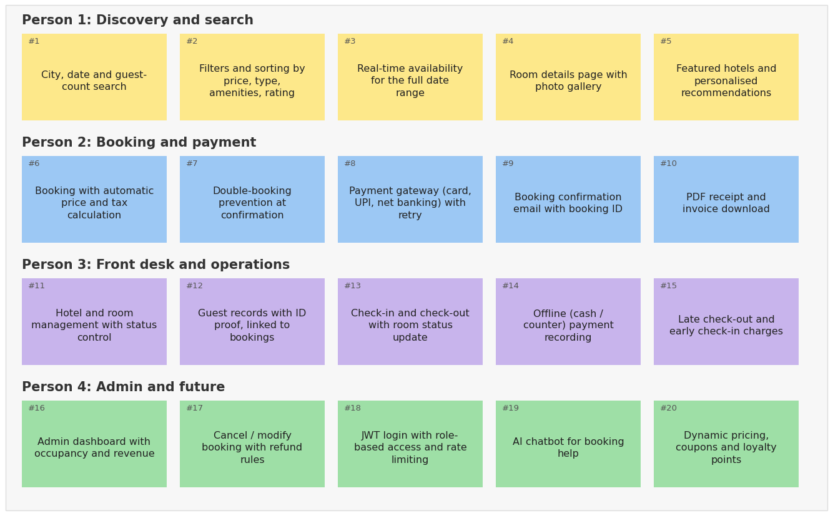
Related ideas were then grouped into six themes:
Theme | Ideas | Count
A. Discovery and search | #1 City, date and guest-count search; #2 Filters and sorting by price, type, amenities, rating; #3 Real-time availability for the full date range; #4 Room details page with photo gallery; #5 Featured hotels and personalised recommendations | 5
B. Booking and checkout | #6 Booking with automatic price and tax calculation; #7 Double-booking prevention at confirmation; #8 Payment gateway (card, UPI, net banking) with retry | 3
C. Confirmation and after-booking | #9 Booking confirmation email with booking ID; #10 PDF receipt and invoice download; #17 Cancel / modify booking with refund rules | 3
D. Hotel and front-desk operations | #11 Hotel and room management with status control; #12 Guest records with ID proof, linked to bookings; #13 Check-in and check-out with room status update; #14 Offline (cash / counter) payment recording; #15 Late check-out and early check-in charges | 5
E. Admin, security and insights | #16 Admin dashboard with occupancy and revenue; #18 JWT login with role-based access and rate limiting | 2
F. Future innovation | #19 AI chatbot for booking help; #20 Dynamic pricing, coupons and loyalty points | 2
Observation: themes A and D hold the most ideas (five each), while theme B is small but contains the riskiest items (#7 and #8), because double bookings and failed payments are the core problems the SRS sets out to remove.
Step-3: Idea Prioritization
Each idea was scored from 1 to 5 for impact (how much it helps users and the business) and feasibility (how easy it is to build within the semester using React, Node.js/Express and MongoDB). The score is impact x feasibility, and the matrix places each idea in a quadrant.
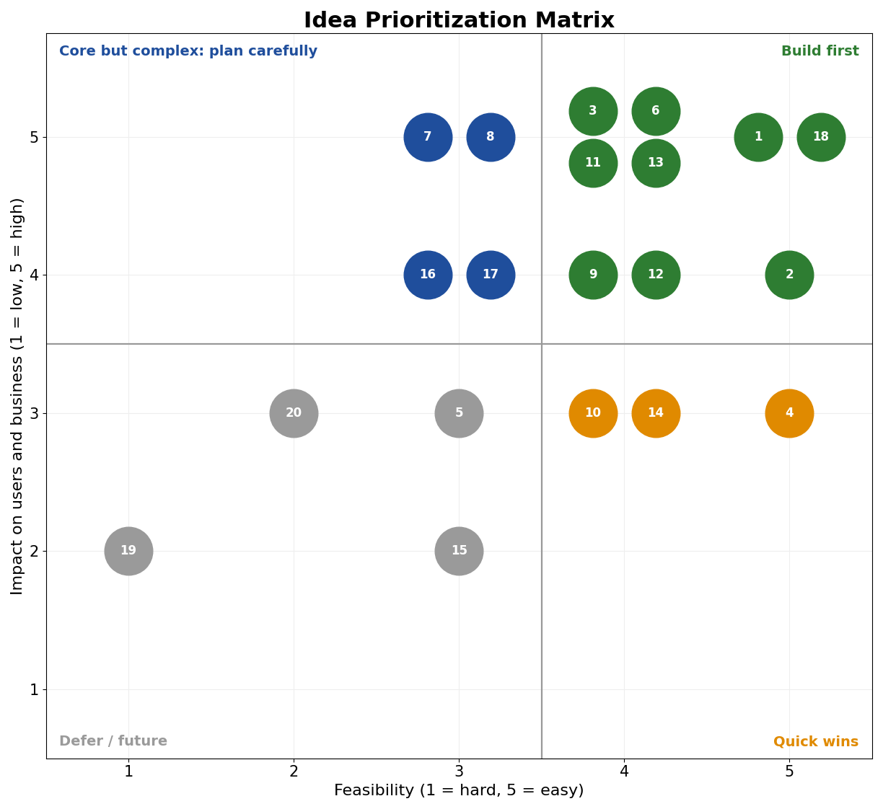
Prioritized idea list (sorted by score):
ID | Idea | Impact | Feasibility | Score | Quadrant | Decision
#1 | City, date and guest-count search | 5 | 5 | 25 | Build first | MVP - Sprint 2
#18 | JWT login with role-based access and rate limiting | 5 | 5 | 25 | Build first | MVP - Sprint 1
#2 | Filters and sorting by price, type, amenities, rating | 4 | 5 | 20 | Build first | MVP - Sprint 2
#3 | Real-time availability for the full date range | 5 | 4 | 20 | Build first | MVP - Sprint 3
#6 | Booking with automatic price and tax calculation | 5 | 4 | 20 | Build first | MVP - Sprint 3
#11 | Hotel and room management with status control | 5 | 4 | 20 | Build first | MVP - Sprint 2
#13 | Check-in and check-out with room status update | 5 | 4 | 20 | Build first | MVP - Sprint 5
#9 | Booking confirmation email with booking ID | 4 | 4 | 16 | Build first | MVP - Sprint 5
#12 | Guest records with ID proof, linked to bookings | 4 | 4 | 16 | Build first | MVP - Sprint 5
#4 | Room details page with photo gallery | 3 | 5 | 15 | Quick win | Include - Sprint 2
#7 | Double-booking prevention at confirmation | 5 | 3 | 15 | Core but complex | MVP - Sprint 3
#8 | Payment gateway (card, UPI, net banking) with retry | 5 | 3 | 15 | Core but complex | MVP - Sprint 4
#10 | PDF receipt and invoice download | 3 | 4 | 12 | Quick win | Include - Sprint 5
#14 | Offline (cash / counter) payment recording | 3 | 4 | 12 | Quick win | Include - Sprint 4
#16 | Admin dashboard with occupancy and revenue | 4 | 3 | 12 | Core but complex | MVP - Sprint 6
#17 | Cancel / modify booking with refund rules | 4 | 3 | 12 | Core but complex | MVP - Sprint 5
#5 | Featured hotels and personalised recommendations | 3 | 3 | 9 | Defer / future | Basic featured-hotels version - Sprint 6
#15 | Late check-out and early check-in charges | 2 | 3 | 6 | Defer / future | Future enhancement
#20 | Dynamic pricing, coupons and loyalty points | 3 | 2 | 6 | Defer / future | Future enhancement
#19 | AI chatbot for booking help | 2 | 1 | 2 | Defer / future | Future enhancement
Conclusion:
- Ideas in the Build first and Core but complex quadrants form the minimum viable product: login with role-based access, hotel and room management, search and filters, real-time availability, booking with double-booking prevention, payment, check-in and check-out, cancellation with refunds, confirmation emails and the admin dashboard.
- Quick wins (room photo gallery, PDF receipts, offline payment recording) are added when sprint capacity allows.
- Recommendations start as a basic featured-hotels version; late check-out charges, dynamic pricing with coupons and loyalty points, and the AI chatbot are recorded as future enhancements, as listed in the SRS.
- Core but complex ideas, especially double-booking prevention and payment handling, receive early testing because MongoDB does not enforce relational integrity and these carry the highest risk of booking errors.

